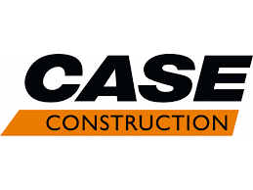

INDUSTRIAL TRAINING REPORT

ON

“PRODUCT ENGINEERING AND MANUFACTURING”

CASE NEW HOLLAND CONSTRUCTION EQUIPMENTS PITHAMPUR (MP)

Submitted By :
UTKARSH SHARMA(IET DAVV) SAMARTH AGRAWAL(MANIT)
MITHIL SAWAITUL(IIT BOMBAY) ARPITA KUSHWAHA(SGSITS)

DEPARTMENT OF MECHANICAL ENGINEERING

TABLE OF CONTENT

- DECLARATION…
- ACKNOWLEDGMENTS…
- CERTIFICATE…
- MAIN BODY... INTRODUCTION COMPANY OVERVIEW
WHAT IS CONSTRUCTION EQUIPMENT LOGISTICS
FABRICATION PAINT SHOP ASSEMBLY FINAL TESTING
- INDUSTRY IN CASE 4.0… ROBOTICS AUTOMATION
TOOLS
- LEARNING AND OVERVIEW…
- CONTRIBUTION IN COMPANY…
- INTERNSHIP EXPERIENCE…
- CONCLUSION…
- ROLE OF An ENGINEER…
- REFERENCES…

DECLARATION

I Utkarsh Sharma, hereby declare that I complete the internship period (4 weeks) of Case New Holland Pithampur (MP) And is result of self-done work carried out by me under the various guidance of engineers and officers of CNH Pithampur.

Utkarsh Sharma
B.E. 2nd year (4th Sem) Mechanical engineering IET DAVV INDORE

ACKNOWLEDGMENT

Industrial Training is an integral part of engineering curriculum providing engineers with first hand and practical aspects of their studies. It gives them the knowledge about the world and circumstances existing in the company. The preparation of this report would not have been possible without the valuable contribution of the case family comprising of several experienced engineers in their respective field of work. it gives me great pleasure in completing my training at case construction and submit the training report for the same.

I take privilege to express my sincere thanks to Mr. Divakar Pandita sir (Manufacturing Engineer) who constantly supported me and channelize my work toward more positive manner.
I thankful to Mr. Indradeep Arora sir for providing me this opportunity which surely helped me in the future.
CHAPTERS

INTRODUCTION

Case new holland: CNH
Case new holland (CNH) is a global leader in the capital goods sector that designs, produces and sells agricultural and construction equipment, trucks, commercial vehicles and specialty vehicles.
Formed in 2013 through the merger of fiat industrial and CNH global, CNH industrial operates under several brands, including case IH, new holland agriculture, case construction equipment, and new holland construction.

Key points
- industry scope: CNH industrial serves the agriculture, construction, commercial vehicles and powertrain segments.
- Global presence: the company operates in over 180 countries with a significant manufacturing and r&d footprint globally.
- Innovation focus: CNH industrial invest heavily in research and developments to drive technological advancements and sustainable practices in its products.
- Workforce: the company employes tens of thousands of people worldwide, fostering a diverse and inclusive work environment.
- CNH industrial’s commitment to innovation, sustainability, and customer satisfaction makes it a prominent player in the capital goods sector.
COMPANY OVERVIEW
Company Overview: Case new Holland
- Company Name: Case new Holland (CNH)
- Introduction: CNH is a leading manufacturer and supplier of construction and agricultural equipment, serving various industries worldwide.
- History: Founded in [Year 1842]
- Company vision: CNH industrial aims to be the preferred choice for the customers seeking cutting-edge equipment and services
- While serving as a responsible and sustainable leader in the global capital goods industry.
- Company mission: CNH industrial is dedicated to delivering innovative and sustainable solution that empower customers and contribute to the advancements of global capital goods industry.
- industry: construction and agricultural equipment
- primary activities: design production, marketing sales and financing of commercial vehicles and equipment
- Product range:
Construction equipment: excavators, dozers, graders, wheel loaders, backhoe loaders, skid steer loaders.
Agricultural equipment: tractors, harvesters, planting and seeding machinery
- Global presence:
over 11,500 dealers and distributors in 170 countries 37 manufacturing facilities worldwide
- Sustainability: recognized in the Dow jones sustainability indices for its efforts in sustainability
- Revenue: $ 23.5 billion in 2023

What is a Construction equipment?

Construction equipment refers to machinery and tools used for various construction activities. these machines are design to perform specific task related to construction, including excavation, grading, demolition, material handling, and paving. common types of construction machines which made in CNH Pithampur is.
Chain Excavators: Used for digging and moving large amounts of earth.
Backhoe Loaders: Versatile machines with a digging bucket on the front and a small backhoe on the back.
Vibratory compacters: Used to compact soil, gravel, concrete, or asphalt in construction project.
Skid steer loader: A compact construction equipment used for a wide range of tasks. It is characterized by its small, rigid frame and lift arms to which various attachments can be fitted.

PRODUCTS:

Chain Excavators (CHEX) Backhoe Loaders (TLB)
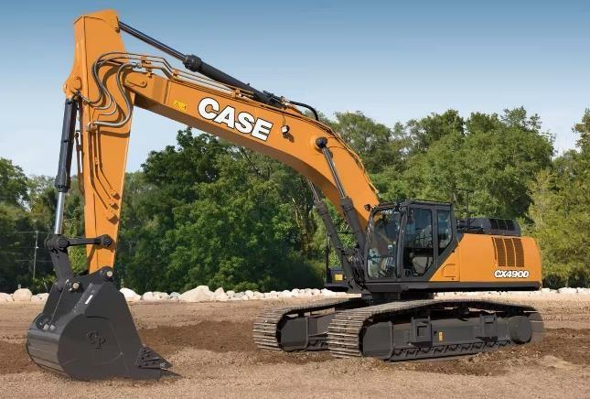
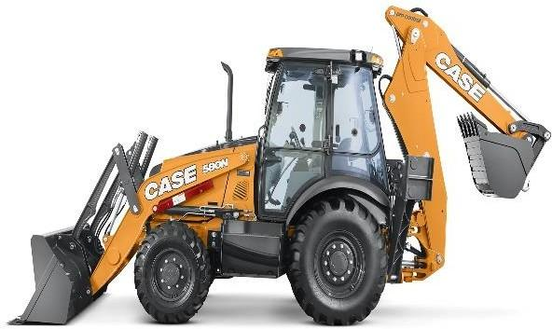
Fig Fig

Vibratory Compactor (VC) Skid Steer Loader (SSL)
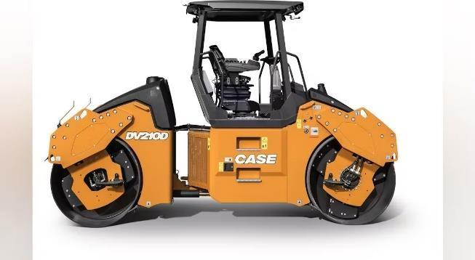
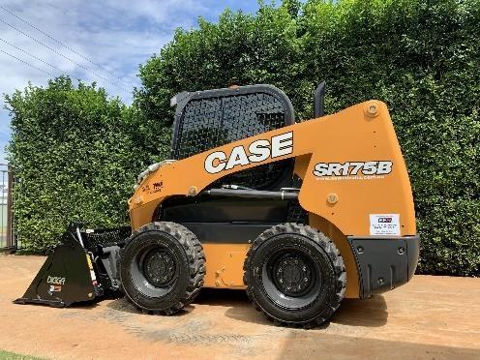
Fig Fig

HOW WE MADE THEM IN CNH PITHAMPUR PLANT
- Raw material and parts come in logistic Department.
- Chassis and backhoe welded in fabrication department.
- Passes through a quality check.
- Comes in paint shop.
- Again, passes through quality check.
- Comes in assembly line.
- In assembly line different parts of machines assembled and machine is made here.
- Then new prepared machines come for final testing.
- Now machines are ready to go in market.

LOGISTIC
This department is responsible for providing the all-raw material to fabrication and part of machines to assembly line. Also, this department keep all the data of spare parts and all small parts which important of making machines like washer, stickers nut, bolts etc.
This department have large warehouse for keep parts and amenities which called supermarket.
Also, this department handle the transporting of parts to the main line according to the plan. For making it easier they have transporting equipment’s some of are:

Fork Lifts | Machine have a loader look like a fork which can lift the parts at height and put down  the part from height | Godrej
Master Movers | A power full electric power machine use for pulling heavy  loads | Master mover.com
Ev Loaders | An electric 3-wheeler  machines for pulling numbers of trollies | Godrej
Trollies | A simple 4-wheel man  powered vehicle for parts | CNH Design
Over Head Cranes | For lifting heavy parts at the  line | Damage

FABRICATION

Fabrication: Fabrication refers to the process of creating or manufacturing something. Often involving raw material or components, through various techniques and methods like Welding, Cutting, shaping, griding etc.
In fabrication parts of TLB, CHEX, SSL are fabricated. All parts of VC are come from substitute companies.
Parts which fabricated in Fabrication.

MACHINE | PARTS | Types
TLB | Chassis | Slide Frame,  Center Pivot
 | Front loader | Radial, Vertical
 | Boom
 | Dipper | Simple, For Hammer
 | Extend-Hoe (Male+ Female)
CHEX | Chassis | Lower, Upper, X  Frame
 | Boom
 | Arm
SSL | Chassis | Upper Chassis,  Lower Chassis
 | Fender | Right, Left Both
 | Radial Tower | Small, Big
 | Front loaders | Radial, Vertical

List of machines

Laser cut machine
Gas cut machine
Single column boring | SHW
Double column boring
machine
welding robots | Cloos, IGM,  Kawasaki
Mig welding m/c
manipulators | Panasonic,  Lincoln

Welding method used – MIG welding Process for fabrication parts:
- Cut by Laser if thickness below 10 mm if not then cut by Gas cut machine
- In welding section there are three processes
  - Tack welding: making small dot like structure for joining
  - Pre welding: MIG welding by worker preparing for final welding
  - Robot welding: final finish welding sone by welding robots
- Inspect the quality of welding quality team
- Grinding in last for surface finishing.
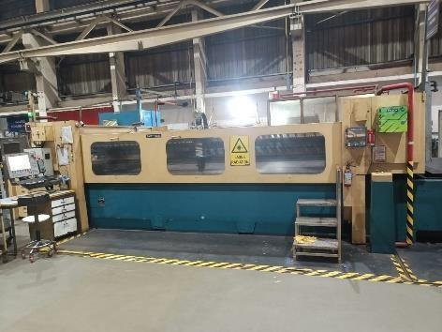
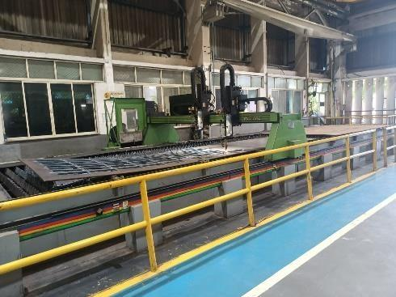
Fig. lese cut m/c Fig. gas cut m/c

PAINT SHOP
After the welding welded chassis and parts come in the paint shop. Paint shop process: -
- roller frame picks up station – it picks the part for process
- shot blasting machine- for even finish the surface of part high carbon steel abrasives hit on the surface for 15 minutes approx.
- air blow station-1-surface finish with air blow
- pretreatment line-
- degreasing chamber -
- DM water chamber
- Ox silane chamber
- DM water chamber 2
- Air blow station 2
- Water dries off oven-120 C
- Powder coating booth 1-50c +- above (dry process)
- Powder coating booth 2 colored powder (dry process)
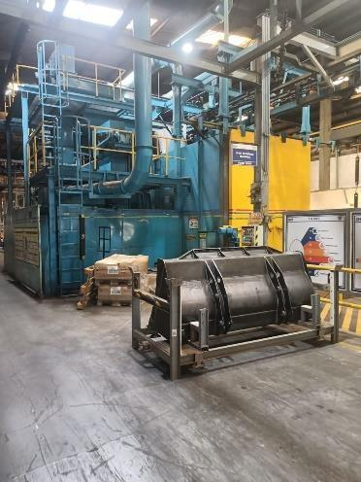
- Vacuum oven – addition of powder at 200c Cooling chamber 34c air is blown different outlets
fig. shot blasting m/c

ASSEMBLY LINE

CHEX
Chain excavator

Engine | 6 Cylinder 154 HP liquid cool engine (FPT, AL)
radiator | Multiple Heat Exchangers for coolant, Hy oil, engine  oil, CAC, Transmission oil
Distributer | For Hy. oil distributing in various parts
Tanks | Diesel, Hy oil tanks for Hy parts
Lower Frame | For moving with chain and rotating the machine
Cabin | For operator comfort and all control at one place
Boom-Arm-Bucket | Main part for digging work
Chain is a big digging machine used for mountains and other off road digging work Major Parts

Frames

Radiator

engine
Distributer
tool box
cabin

Tanks
Lower frame
Boom-arm

Sub part of CHEX

Engine | Compressor Alternator Starter motor Turbocharger Cooling fan  Fuel injection system pump
Radiator | Condenser Heat exchanger  CAC system hoes heat exchanger
distributer | Hosses Joints  Solenoid valves  Control valves
Tanks | Diesel tank  Hy oil tank Tool Box
Lower Frame | Spure  Travel motors Idler  Rollers Supporter rollers Centre joint Swing motor
Cabin | Joy stick Seat  Control panel Cabin frame
Boom-Arm-Bucket | Hydraulic cylinders Boom  Arm  Bucket side link bucket

CHEX CENTRE SWIVEL JOINT
The cabin of the CHEX can rotate 360^{O} with his boom and arm but its Hy oil distributer and cabin situated in upper part and drive motor is in lower part attached with chain, drive motor connects with multiple hoses with cabin and then distributer then due to the rotation of cabin these hoses can easily damage and brake.
For preventing this a mechanism is attached in its center at the slew ring near the swing motor called center swivel joint.
In center swivel joint rings likes structure is made total no. of these structure is 4 in case CX210 each for one hose. Lower hosses is connected with these rings permanently and does not rotate and upper hose connections can slide on these rings and thus they can rotate freely in all directions with the upper chassis.

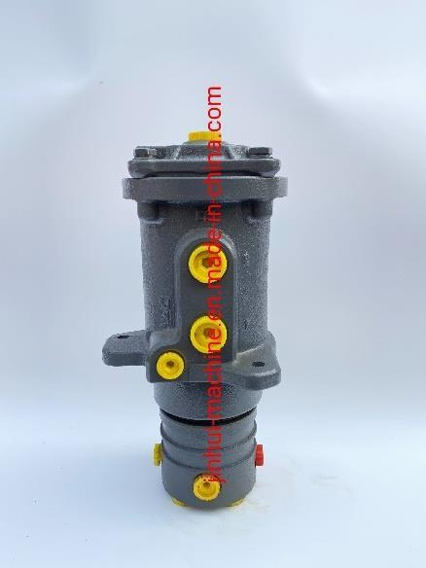
Fig center swivel joint

TLB

Tractor Loader Backhoe is the multipurpose tractor attached with a loader and a Backhoe for small digging for lifting and transporting the digging west. we can use it as a drilling equipment attaching with a hammer or a drill

Major parts of TLB: -

Chassis | Part on which all the component of machine attach
Spool valves | For distributing Hy oil in Hy parts
Axles Front & Rare | For moving and transporting the m/c (CA, NH)
Engines | 4 cylinder inline 96 hp liquid cool engine (FPT, AL)
Slide Frame | For bearing the load and moving of backhoe
Radiator | Multiple Heat Exchangers for coolant, Hy oil, engine oil, CAC, Transmission oil
Fix hood & Tilting hood | For easy repairing of machine
Tanks | Diesel, Hy oil tanks for Hy parts
Front Loader Arm | Radial and Vertical loader for loading work
Backhoe Dump Bucket | For carrying mud or any material
Cabin | For all controls and Operator
Tyers | BKT, CEAT tyers
Backhoe | For digging and other work
Extended hoe | A special part which can extent up to 3-4 feet

Sub Parts of TLB: -

Chassis | Chassis frame Stabilizer parts Leg  Foot  Hydraulic cylinders types:2  Spider type
Spool valves | Hoses Pins Joysticks  Safety valves  In/out valves
Axles Front & Rare | Rare axle Hub Knuckle Differential  Brake Hydraulic plate Shaft  Knuckle joint | Front axle parts  2 way Hydraulic cylinder  Piston rod Hub Knuckle  Shaft (for 4 wheel drive)
Engines | Compressor Alternator Starter motor Turbocharger Cooling fan  Fuel injection system  Main Pump & steering pump  EGR system (exhaust gas recirculation)
Slide Frame | Swing tower Swing cylinder Slide frame  Support piston
Radiator | Condenser  CAC system (hose and heat exchanger) Coolant cooling heat exchanger  Hy oil cooling heat exchanger

 | dryer
Fix hood & Tilting hood | Air filter Primary air filter Muffler  Air breather tilting hood  doc
Tanks | Diesel tank Hy oil tank Level gauge  Bracket for stairs Cover both
Front Loader Arm | Hydraulic cylinder  Backhoe dumb bucket (2 types) Safety lock  RTD sensor(bs4)  Anti roll stick and anti roll
Cabin | Cabin structure  Break accelerate paddle Evo prater  Switches Flanges Music system Steering  RTD sensor
Tyers | BKT tyers  CEAT tyers
Backhoe | Boom Dipper  Bucket side link Bucket (24/28,32,34)  Hammer connection (at dipper)
Extend hoe | Male part Female part  Cylinder

HYDRAULIC SYSTEM OF TLB
Hydraulic system is the heart system of the machine all heavy work done by this machine is possible due to the proper functioning of all hydraulic component of the machine
Hydraulic system parts
- HY Oil Pump
- Hosses
- Spool Valve
- Cylinders

HY Oil Pump: - gear pump, variable displacement pumps Variable displacement pump
- Hydraulic fluid enters in the pump through inlet
- The fluid is drawn into a cylinder block containing multiple pistons
- The pistons reciprocate, driven by a rotary input shaft
- The piston stroke length varies, depending on the pressure requirement
- The fluid is discharged at a variable flow rate, matching the system’s demand.
- A load-sensing valve adjust the piston stroke to maintain constant pressure Gear pump
  - Hydraulic fluid enters the pump through the inlet.
  - Two intermeshed gears rotate, creating a vacuum at the inlet.
  - Fluid is drawn into the inlet the gear teeth and carried around the circumference.
  - The fluid is pushed out of the gear teeth and into the outlet.
  - The gear rotation creates a constant flow rate, regardless of system pressure

Variable displacement pump can adjust the flow rate as per the pressure requirement and gear pump maintain a constant flow rate, regardless the pressure.
Hosses: -it can say the upgraded version of tubes it made for bearing high pressure of Hy oil it made of rubber on outer part and inner is a netlike structure made with wires with nuts and connectors at the end
Spool valve: -spool valve which control the flow of Hy oil in hoses and then backhoe and loader arm it has pin & levers attached for controlling the flow also for safety each hole has a return valve and a main return valve is available in spool valves
Cylinders: -boroll and piston assembly connected with hose the pressure is create in cylinder which lift the load, pressure of cylinder depend on area of piston and load on the piston.

The hydraulic system is work on the principal of pascal’s law which says “the pressure applied to an enclosed fluid will be transmitted without a change in magnitude to every point of the fluid and to the walls of the container.
“P1=P2”

6/7SPL

2/3SPL

Pump
Tank

Hydraulic circuit

Backhoe

Loader Arm

for load
Radiator
Filter

In TLB steering system and brake system is also hydraulic

VC

Vibratory compactor is a compacting machine majorly used in road construction earth work. Single roller used for soil compacting and double roller compacter used for road compacting. They also have a special feature of vibrating of the roller at their exes.

Major parts of Vibratory Compactor 1107Ex, 952Ex, 450Dx
Rare chassis – front chassis | Part on which all the component of machine attach  And Front chassis is for rollers
Axle | For tyers in 1107Ex
Roller | The part which vibrates and compress the soil
Engine | 4 cylinder inline liquid cool engine
Radiator | Multiple Heat Exchangers for coolant, Hy oil, engine oil, CAC, Transmission oil
Cabin | For all controls and Operator
Hood | For covering the engine and other parts


















Chassis work
Axle/rollers
Engine &
radiater
tanks
Hyroulic
connection
Operator
cabin
Battery
connection
Powering
fueling

VIBRATION OF ROLLER
The most important part of a VC is that his Roller which can vibrate at his axis. In the roller have a Travel/Drive motor one side and a Vibratory motor other side with travel motor a fan like structure is attach which connect with whole roller and through this structure rotate it rotate with whole roller and VC moved forward and backward.

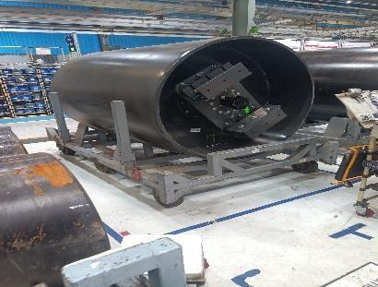
Fig. Roller with vibrating motor

VIBRATION METHODOLOGY
For the vibration of roller have a hollow space provide in the center in which an eccentric shaft is fitted which connect with vibratory motor. Vibratory motor connects only with shaft not with roller due to this it only can rotate the shaft itself and due to imbalance weight due to the eccentric weight a force is generated which is imbalance and this force vibrates the roller and also pin bearing and supporters is attached for bear the force generated due to vibration and prevent any damage due to this

CALCULATIONS
Eccentric distance = e Eccentric mass = m
RPM of shaft = N, ω=2πN/60
Centrifugal force formula = mrω² , where, e = r
With this formula force of roller due to vibration = meω² Intensity of vibration = I = power/surface area
Power = force * velocity =
mr²ω³

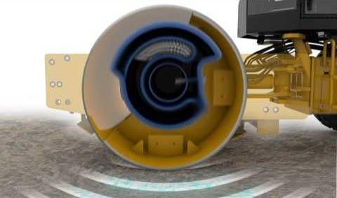

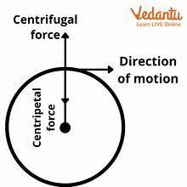

Now with these relations we can the find other factors of vibrating of rollers to like force acting on roller, fatigue, no. of cycles, design and material of eccentric shaft etc.

SSL

Skid Steer Loader a special type of small machine used in industries for mostly loading the small items and transport light wight material in narrow streets and place. The special feature of this machine is her driving system it has no steering for turning and no accelerator paddles.
It has joystick for drive and also for turning we can turn it on its own axis by moving the joystick in opposite direction. SSL tyers skid they not turn that’s wHy it’s called skid steer loader.

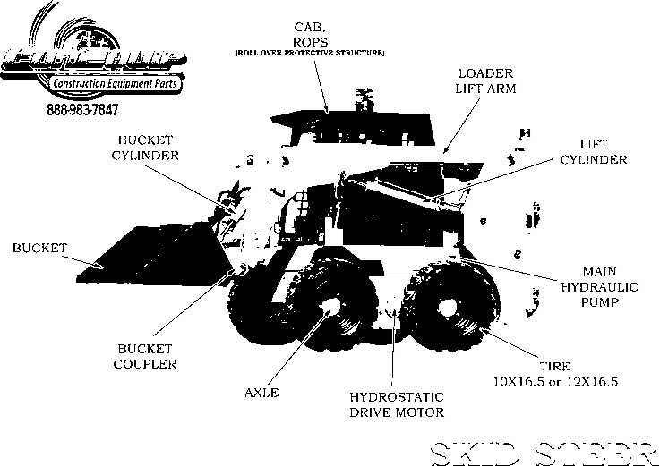

Major parts of Skid Steer Loader

Lower Frame | For assembling engine, hosses
Upper Frame | For assembling cabin
Engine | 4-cylinder inline 60 hp liquid cooled, by parkin’s
Harnesses | Electrical circuit, wires
Distributer | For distributing Hy oil
Drive motor | For driving the tyers with drive chain
axle | For tyer assembling

Fender/Radial Tower | Diesel, Hy tank is fitted in them
Loader | For loading and transport material
Cabin | For driver comfort and controls
Joystick, Lever | To drive machine and for turning

SSL Driving mechanism
SSL’s unique feature is its ability to turn by differential steering: Both the wheels on one side of the machine rotate inn opposite direction allowing the machine to turn sharply.
This mechanism enables the SSL to:
- Move forward and backward
- Turn sharply
- Lift and lower loads
- Perform various tasks with attachment like buckets, forks and augers and rock breakers.
Driving mechanism consist various important parts like: -
- Joy sticks: to give command to wheel and machine
- Solenoid valve: to control the flow of Hy oil flow in hydraulic motor with electronic signals
- Drive motor: power the wheels for moving and allows moving forward and backward
- Independent axle: to turn wheels independently and make possible to turn the machine sharply.
Working: - there is pump in machine for providing fluid pressure to the wheels as well as loader arm by moving the joystick which electrically connects with solenoid valve. By moving it solenoid valve control the fluid flow in hydraulic motor for backward and forward which moves the drive motor 1 drive motor for each side of wheels means both side of wheels can move Independently but one side of wheels are dependent on the side of motor on which they attach. And in
cabin two joystick given 1 for each side left joystick for left side and right for right side. Now by moving both the joystick forward can move wheels forward and for back move joysticks backward. Now for turning just move one side of joystick due to this only one side of wheels are moving and other side of wheels are in rest and if we move both joysticks in opposite direction then machine turn on its own axis.
For controlling the front loader, we use joysticks by moving them right or left we can control the loader and bucket. Left joystick is for controlling the bucket and right joystick for loader arm.
This machine has a special feature called ISO by switching to this mode we can control driving and turning by only one joystick which is the left joystick and by only the right-hand joystick we can control the loader arm and bucket.

FINAL TESTING AND WASHING

After completing the machines comes for testing. here they test their load capacity, leakages, roughness etc.
they tested them around 1 hour of rough testing they pass through Final Inspection and last Pre-Dispatch Inspection.
Here we check their functioning, working and see is they functioning correct and any type of leakage etc.
If any malfunctioning found in parts it will correct here. And in the last wash them and refill the coolant, Hy oil.

INDUSTRY 4.0
4TH Industrial Revolution is the term used for Industry 4.0. it can be defined as the integration of intelligent digital technologies into manufacturing and industrial processes.it is a new phase in industrial revolution that introduce networking of machine and processes for industry with the help of information and communication technology.

What is industrial revolution
Industrial revolution is defined as the major changes and transition in manufacturing and industrial process with new innovative technologies.
Sequence of all industrial revolutions

Industrial Revolutions | About Them | Major Inventions
1st From 1784 | Machines Powered by  water and steam | Steam engines
2nd From 1870 | Electricity & Steel Mass  Production | Steam turbines,  Generators
3rd From 1969 | Electric Automation  Computers | Computers
4th From 2010 – present | Cyber-Physical System, Advanced Robotics, AI& ML | Robots


KEY TECHNOLOGIES

Internet of Things








aggumentet
reality
Advanced
Rboticss
Industry
4.0
Additive
Manufacturing
Artificial
Inteligent
Cyber Security
Cloud
Computing

Application of Industry 4.0 in Case
The industry 4.0 also applicable in Case Construction in sort of manufacturing technics, testing procedures, R&D, Fabrication department etc.
Here they use Automation, Robotics, Machine Learning, High Tech Tools in their production, testing and R&D works.

AUTOMATION
Automation in industry 4.0 refers to the use of technologies such as industrial internet of things (IIOT). Cloud computing, artificial intelligence, machine learning and robotics to enhance manufacturing processes.
Aim of automation is to:
- Increased the efficiency and productivity
- Improved product quality
- Reduced labor costs
- Enhanced flexibility and customization
- Improved date-driven decision making
- Increase competitiveness
- Scalability and reconfigurability
- Improved safety and security. Examples of automation in CNH
Laser cut machine: it is the machine which cut the metal sheet automatically after giving one time command with laser technologies.
Paint shop air blow and dm water machine: in paint shop these machines automated work and spray dm water also dry in air blow chamber.
Conveyer chain: conveyer chain automatically passes through all material processes with the part by in set time.
Conveyer belt or path in TLB and VC: in these lines conveyor belt and path is assembled for moving the machines to all stations without any human interference, they set a specific time period in them and then conveyer moves itself and also can stop from various points in case of emergency

DC TOOL
DC Tool is a pneumatic automatic torquing hand a special automated current powered machine made by Atlas Copco It use for give a specific range of torque in a specific order which can set by operator once then no human interference need for any chances only at the time of tighten the heavy bolt a person is needed for handling or for any emergency situation.it have a sensor for sockets if we attach the right socket then only machine start and tight the bolt if not then machine can’t be operated.
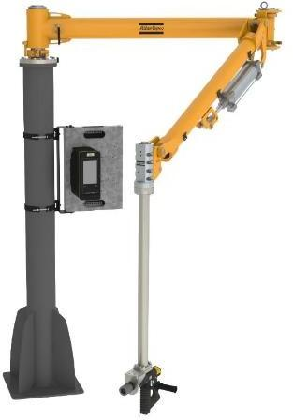

Machine name | DC Tool (Automated Pneumatic Hand)
Make | Atlas Copco
Function | To tighten the crucial Bolts where a specific torque is  needed
Torque Range | 60 kg, 600 N
Power type | Electric and pneumatic for hand

For operating dc tool first choose the correct set function for the part then just handle its arm and attached right socket in its handle and put in bolts it automatically tight the bolt and show the sequence on its screen. Then according the screen show attach right socket in machine and let the process repeat and machine complete the process itself.

ROBOTICS
Now a days Robots are widely use in industries for reducing the men effort in low skill work and also it increases the work capacity of plant as robots can work faster and efficient in some of cases where man can’t.
In Case Industries there are several robots are present mostly in Fabrication department where they work in welding processes. In fabrication department Final welding is done by robotic hand which is by Cloos company and some of them is Kawasaki robots.
All the robots have almost same work welding the chassis but of different machine like TLB, CHEX, SSL and also welding for Boom, Arm, Dipper, Extend hoe.
- About the Robots
Here is they are the cloos Robotic hand which called and also some of Kawasaki Robots hand they get their name according to their work like the robot used for the welding of upper part of CHEX called “UPPER-CHEX ROBOT” and same for all like BOOM ROBOT and all.

- Specifications
They all have almost same specification just have they used different codes for their different work

Name - Welding Robo Make - Cloos, Pune
Language used – Corolla (developed by Cloos itself) Teaching method – coordination method
Major parts – Actuators, Servo Motors, Step Motors, Sensors, Hand, Pillar, Manipulator, MIG Wire, Controller, CPU, etc.

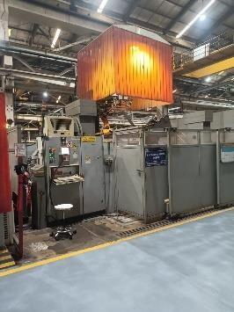 Fig. Cloos welding Robot

TOOLS
Tools played a major role in making a machine in mass production faster and sophisticated without some of tools a machine part cannot fit in the machine properly for example a nut bolt in the axles which takes the tons of loads it should have given a sufficient torque so that it placed properly and do not misplace during the heavy operations which a man cannot do it manually.
In case construction the tools are also advanced like wi-fi gun which can store data of work and also shutoff or auto cut off gun which automatically cut down the torque at a certain limit.
Tools

Torque Wrench | A wrench made for specific torque; a click sound come at the  torque limit | Tackton,cdi | 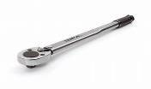
Angular Gun | A gun which can give torque at a angle mostly 90  degree | Atlas Copco | 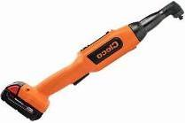
Pneumatic Gun | Gun which powered by  compressed air and run by a impellor | Atlas Copco, panasonic | 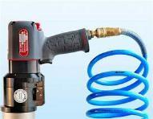
Battery Gun | Gun which powered by lithium-ion batteries and run by motor and  brush less motor | Milwaukee  ,Panasonic, Ingersoll rand | 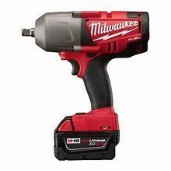
Impact gun | Gun which gives torque by its  hammer-like design in it | Bosch, makita | 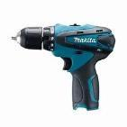

Auto cut Gun | Gun which cut off the torque at a limit | Panasonic, atlas | 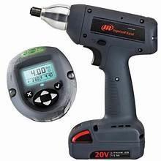
Wi-Fi gun | A smart gun with some useful features | Panasonic | 

PRODUCT DEVELOPMENT AND VALIDATION
Product development
In CNH R&D department is called product development department.in this department new product is developed and done research about them, also all engineering work of machines is done in this department. also new technology of machines also developed and improved with this department.

Product Validation
This department is responsible for testing of new machines and technologies of machine. After the design and making of new product from PD department the new product comes in this department here engineers tested the new product and also perform experiments with them. Also, in this department new and different parts is tested with machines.

These department can call the brain of CNH plant most of skilled engineers are posted in this department. If you learn about working of machine and about new technologies used in these machines then these are the best departments for learning.

MANUFACTURING DEPARTMENT
Manufacturing engineering is the department which allotted to me I can say that it is the best department in terms of learning and also the work culture of this department is best among the all departments of CNH.
The work of this department is to execute the plans of production engineering team on the assembly line, they provide all the facilities at the line which contribute in manufacturing of machines at mass level with perfection and given target time.
The facilities include:
- conveyer platform
- balancers
- Centre cranes
- torque wrenches
- torque guns
- pneumatic guns
- angular guns
- air compressors
- dc tools
- punching press
- oil fuel machines
- brake bleeding machine
- no. plate machine
- manipulators.

The department also design the other facilities which indirectly help in manufacturing and testing of parts
- Kanban trollies
- Specific load trollies for each part
- Tackles for lifting the heavy parts
- Testing gadget and gauges for bolt nuts etc.
- Color codes for bulbs and on lifting chains

LEARNING AND OBSERVATION
Internship period is the crucial time and opportunity for knowing about cooperating world and attach your knowledge with practical things to see and learn how actually things works in a company at big level.
During my 2-month period I learn lots of new things and technologies of machines also spend valuable time with colleagues and see how to behave and manage the workload and pressure in company which eventually beneficial for me in my professional life.
If we talk about technical things then can explain in following terms:
- Learn Creo PTC software which use many MNC companies.
- Learn tool design mainly torque wrench
- Learn making standard operating procedure sheet for line
- Making planes for assembly lines for improving production efficiency and also apply it on assembly line
- Learn about hydraulic system of TLB, steering mechanism of SSL, and center joint of CHEX
- Study about vibration of Roller and deign the roller also and also calculate important factors of rollers
- See testing of CHEX filter and learn various cost cutting techniques used by engineers
- Learn to control these wonderful machines
- Learn about upcoming EV technology in construction machine and new EV products of CNH
- Vehicle dynamics and engine design and EGR and CAC system

OBSERVATIONS
My observation in companies which can be improve
- Mismanagement of SSL lines
- Mostly on SSL Shortage parts are happening
- TLB’s slide frame hosses are damage prone because they are not covered by any part
- At m10 there is a safety concern due to sharp edge platform

CONTRIBUTION IN COMPANY
I also do a small contribution toward the company by using the learning gain in the company and department
In TLB line at cylinder sub assembly there is two connectors which tight should be at a specific angle which is about 55 degrees. The problem is that how operator know that the connector is perfectly aligned.
For to solve this problem firstly I measure the angles of both connectors fortunately they are just mirrored both sides. Now I designed a plate of 6 mm thickness with a hollow part at the edge equal to the diameter of connector bolt and its angle is 55^{O}.
Since the plate have handle no load, it is just for checking so choosing material is not a big deal we made it by regular metal sheet available in fabrication.
Next thing is to make a reference for plate to measure the angle accurately and same for every connector every time, for that we use the nob of cylinder situated at center of cylinder which is same for all so we measure that distance from connector bolt and weld a plate 90^{O} with a hollow rectangle at Centre for resting.
Now we know there are two connectors which is exact mirror in shape so we just mirror the supporting sheet at 90^{O} an hence our testing gauge us ready for test the connector angle.

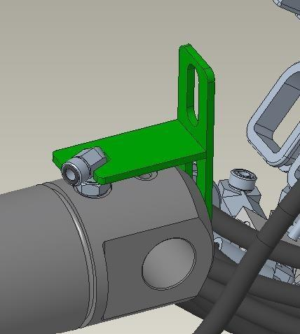
Fig tackle design at testing

CONCLUSION
In conclusion my internship at CNHI has been a highly rewarding experience that has provided me with a comprehensive understanding of the design, development, and manufacturing processes of construction machines. Throughout my 2 months of internship, I have gained valuable insights into the production processes, quality control implemented by the company.
I have had the opportunity to work on various topics which contributed to the development of innovative solutions that enhance the efficiency and productivity of TLB and CHEX. I have gained hand on experience on Creo, different Tools and construction machines which developed a deeper understanding of the technical specifications and applications of various construction equipment.
My internship at CNHI has been instrumental in shaping my understanding of the industry and has instilled in me a passion for innovation and excellence. I am grateful for the guidance and support received from Mr. Divakar Pandita sir and my colleagues, and I am confident that the skills and knowledge gained during my internship will be invaluable in my future endeavors. I look forward to applying the lessons learned and contributing to the growth and success of the construction equipment industry.

ROLE OF An ENGINEER
In a MNC Company like CNH there is engineers all over at almost all major post which linked to the machines we can find a Highly qualified engineer which come from a IIT or NIT or a MTech qualified from a premium collage.
Engineers are not who which manufacture the machine or joint the parts of the machine but the who which make the plan of how a machine should be assembled properly, Fastly and Efficiently also make the standard operating procedures for workers to work more efficient and smoother.
Here are engineers for making the design of the part of machine and also for the tools which used in it and also do research and testing work for new machines models.
So, in brief there have engineers for almost all-important work of machine which improve the performance of machine as well as the plants and they are mostly mechanical engineers.

REFERENCES
Howstuffworks.com CNH I touch
CNH I learn

